MERIDIAN PARK
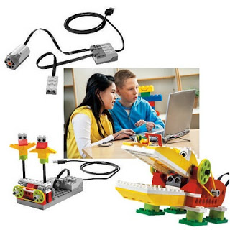
WeDo LEGO CLUB
Attention all 1st-3rd Grade Students!
Meridian Park PTSA is sponsoring a junior robotics class starting soon! Don Gronning of Robot U will introduce basic programming and engineering skills to students through the use of LEGO WeDo, an easy to grasp robotic system that uses a simple graphical interface and motors and sensors to build a series of educational and entertaining robots.
Classes will be held for (8) weeks on Thursdays from 3:35pm – 4:30pm in the Meridian Park Library. Classes begin Thursday, January 14 and will run for eight weeks. Cost per student is $96. To register, please visit www.robot-u.com. For scholarship information, please contact MP Family Advocate Annie Gage at annie.gage@shorelineschools.org or (206) 393-1768. Minimum number of students to hold class is eight. Students who have not taken this class will have priority registration. Questions? Contact Mary Webb at mwebbnd@gmail.com.
Want to be the lead parent (attend all eight classes)? If so, tuition is free! If there is no lead parent, parents will be expected to volunteer for one class.
