
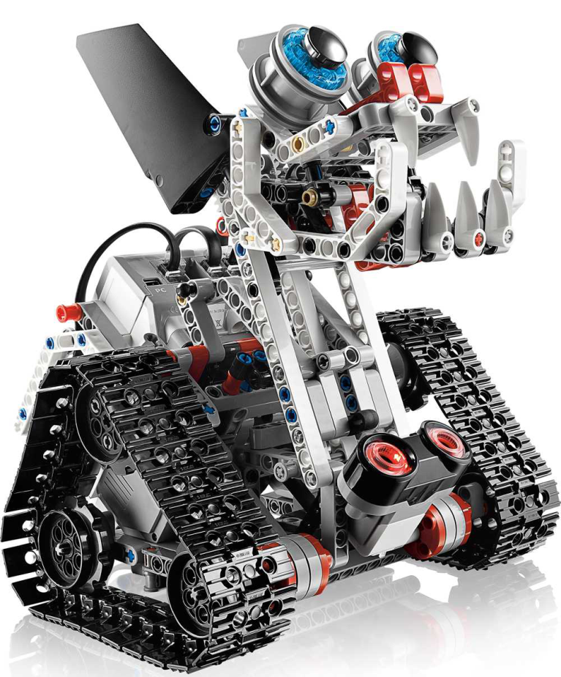
Come join the Fun!
All 4th -6th Grade Creatives, Engineers, and Programmers
Don’t know anything about programming or engineering? We’ll teach you how to build a robot and program it to make it move the way you want it to. The Meridian Park Robotics Club is a community of students exploring programming and engineering together.
∗ The club has ample materials so you won’t be left standing
∗ You’ll be challenged weekly to solve problems and compete with other club members
∗ Learn to lead and be part of a team
This Robotics class is built around LEGO Mindstorms and will be held for (10) weeks on Mondays from 3:35pm – 5:00pm in the Meridian Park Library. Classes begin Monday, January 11. Cost per student is $120. To register, please visit www.robot-u.com.
For scholarship information, please contact MP Family Advocate Annie Gage at annie.gage@shorelineschools.org or (206) 393-1768. Minimum number of students to hold class is eight. Students who have not taken this class will be given first priority. Questions? Contact Mary Webb at mwebbnd@gmail.com.
Want to be the lead parent (attend all ten classes)? If so, tuition is free! If there is no lead parent, parents will be expected to volunteer for one class.


